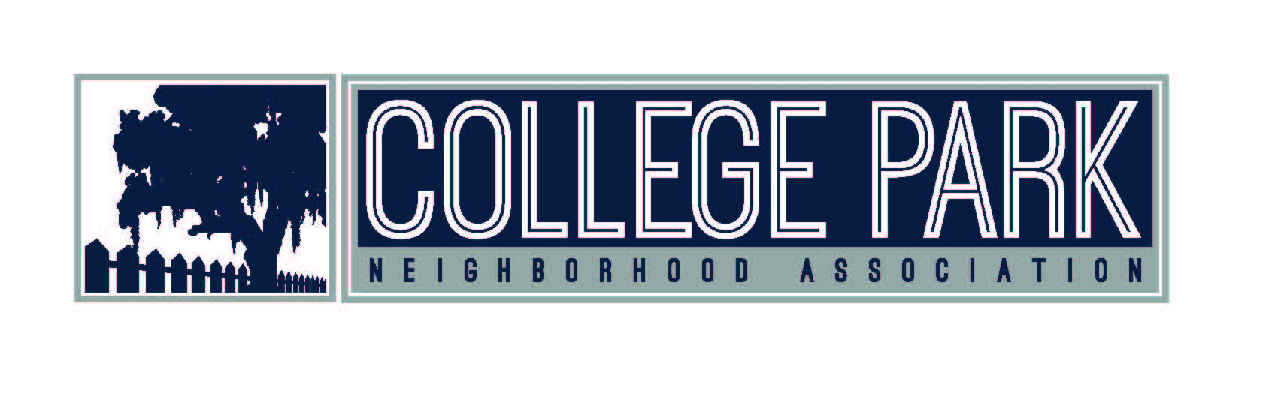
College Park Neighborhood Association
Instructional Mini-Grants for
Projects that Advance History or Service-Learning for the College Park Community

TEMPLATE FOR MICHAEL WELBORN MINI-GRANT PROPOSALS
Rolling Decision

Guidelines: Project can be an academic service-learning experience, community-based research, or creative activity.

All proposals should be electronically submitted as a Microsoft Word attachment by email:Welborn@mycpna.org Proposals will be reviewed by the CPNA Board of Directors

Title

Population Served

Geographic Area Served

Please attach your answers:

1. Description of Project (400 word limit)
Include a description of the proposed area of community-based study and methods of reflection (e.g., journals, threaded WebCT discussions, presentations, class discussions). Indicate how the project fits with the class learning goals for the semester.

2. Implementation (200 word limit)
What stumbling blocks do you anticipate which may hinder the success of the project? Do you have a have an on-going relationship with the community organization(s)? Have you considered the logistics of student travel to community site(s)? How might students sustain their study of local history?

3. Assessment (200 word limit)
Describe how you will evaluate and share the students’ learning outcomes. What assessment means will you use to evaluate student achievement of on-site study and course goals (e.g., assignments, student work, portfolios) and how will positive outcomes be disseminated to the larger community?

4. Funds Requested—Awards of up to a maximum of $500 (200 word limit)
Indicate total amount requested for this project, breakdown of total cost, basis for the cost(s) estimate, and how costs (i.e., sustaining the course, supplies and equipment, personnel assistance) will be covered once project funds are expended.

Signature Date

Director/Supervisor

